Q_3.Process_16/08/22
Write program using C in Linux -
A. That will illustrate the creation of child process using fork() system call.
B. To create a process that creates a child process. Print PID & PPID in each process. Also, verify those PID & PPID values using ps command.
Code:

#include<stdio.h>
#include<sys/types.h>
#include<unistd.h>

int main()
{
int v;
v=fork();
if(v==0)
{
printf("CHILD\n");
printf("Process id of the child : %d \n",getpid());
printf("Parent id of the child : %d \n",getppid());
}
else
{
printf("PARENT\n");
printf("Process id of the parent : %d \n",getpid());
printf("Parent id of the parent : %d \n",getppid());
}

return 0;
}

Output:

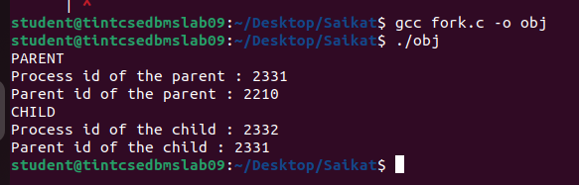

D. Write program using C in Linux to create a zombie process that displays PID & PPID. Verify PID, PPID values & zombie status using ps command.
Code:

#include<stdio.h>
#include<unistd.h>

void main()
{
int f;
f=fork();
if(f==-1)
{
printf("Unable to create new process");
}
else if(f==0)
{
printf("\nChild process");
printf("\nProcess ID=%d, Parent process ID=%d",getpid(),getppid());
}
else
{
printf("\nParent process");
printf("\nProcess ID=%d",getpid());
sleep(20);
}
}
Output:
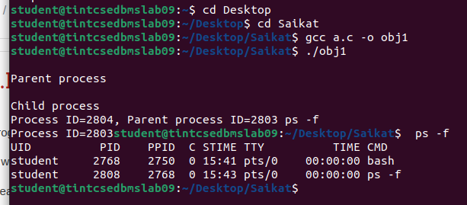
C. Write program using C in Linux to create an orphan process that displays PID & PPID. Verify PID & PPID values using ps command.
Code:
#include<stdio.h>
#include<unistd.h>

void main()
{
int f;
f=fork();
if(f==-1)
{
printf("Unable to create new process");
}
else if(f==0)
{
printf("\nChild process");
printf("\nProcess ID=%d, Parent process ID=%d",getpid(),getppid());
sleep(20);
}
else
{
printf("\nParent process");
printf("\nProcess ID=%d",getpid());
}
//sleep(20);
}
Output:
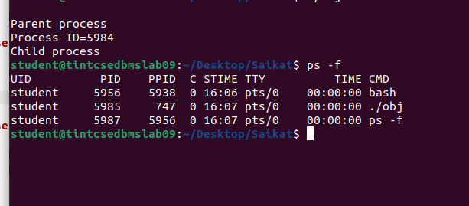
B. To create a process that creates a child process. Print PID & PPID in each process. Also, verify those PID & PPID values using ps command.
Code:
#include<stdio.h>
#include<unistd.h>
#include<unistd.h>
#include<sys/types.h>

int main()
{
int f;
f=fork();
if(f==-1)
{
printf("Unable to create new process");
}
else if(f==0)
{
printf("\nChild process");
printf("\nProcess ID=%d, Parent process ID=%d",getpid(),getppid());
}
else
{
printf("\nParent process");
printf("\nProcess ID=%d,parent process ID=%d",getpid(),f);
}
sleep(20);
return 0;
}
Output:
